Pierce County Fair Demolition Derby
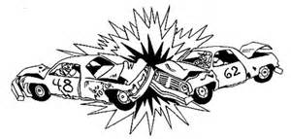
Sunday, July 2
Pierce County Fairgrounds
Chain & Bang and Herby Derby Classes
Cars Need to be at the fairgrounds 1 hour before
Call Lawrence – 701-771-2035

- $75 Entry Fee
- Payout to be determined by car count. If 8 or more cars payout will be larger
1st min. - $500 2nd min $250 3rd $125

Chain & Bang and Herby Derby Rules
- All carpet, cloth, plastic, glass and grilles must be removed
- Cooling systems must remain stock
- Factory fuel tank must be removed, and fuel tank must be relocated to back seat and securely fastened
- No motor Cradles
- Body Seams may not be welded, no welding on caqr other than where specified
- Body may be creased and pre-bent
- Pre run cars – ABSOLUTELY NO PLATING
- Hoods must have at least 18 in. hole in case of fire. Up to two 1” all thread bolts may be used from hood down through the frame at radiator support. Rod sleeves are not allowed. Hoods may be moved forward and bent over the radiator
- Trunk lids may have up to two-1” all thread bolts through frame
- May have dash bar and bar behind drivers seat
- May bolt 6” plate to drivers door not over 4” on either side of seams
- Transmission coolers are allowed
- Suspension/drivetrain – all suspension must remain stock. This is a chain class – no welding! No welding or bolting A-Arms
- No frame altering allowed – No fram seam welding
- Body mounts – mounts may be removed, but no extra bolts may be used NO FRONT END TIPPING
- Bumper – any stock car bumper. Bumper shocks may be collapsed and welded. You may use 2 plates 6” x 12” x ¼” to fasten bumper to car. No loaded bumpers or Homemade bumpers allowed
- No Imperials or Suicide Lincolns
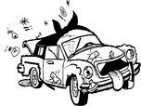
- If car does not pass inspection or make it into arena, no refund of entry fee
- Stock rear ends, NO floater or ¾ ton rear-ends

